CURRICULUM VITAE : Anouk Danthe & Olivier Leu

Olivier Leu
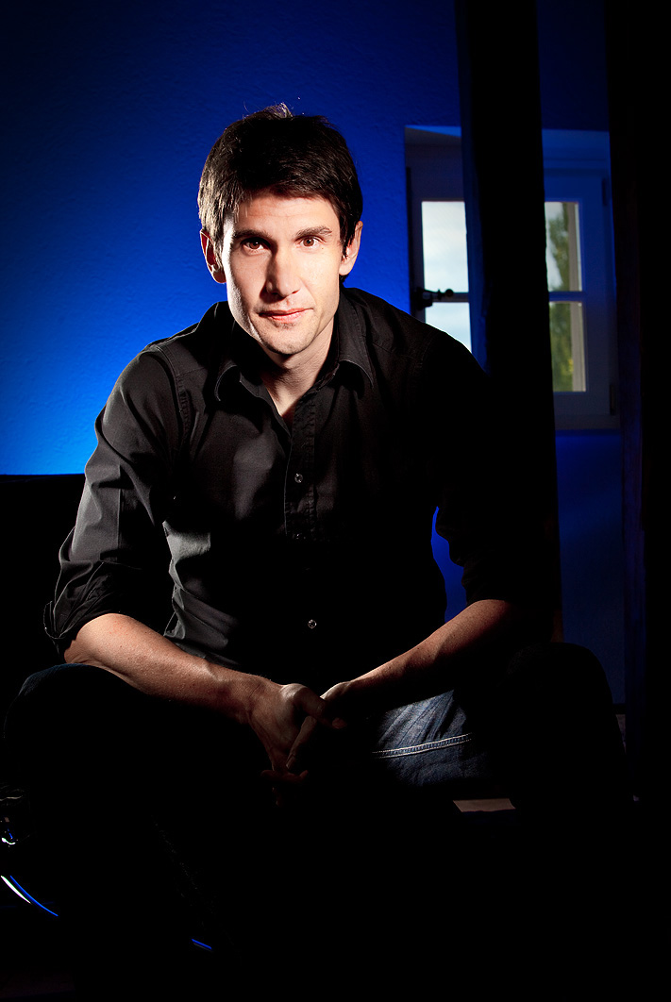
Born : Lausanne - Switzerland
Nationality : Swiss
Date of birth : 23 juillet 1970
Private : Single, in couple with Anouk Danthe since 1997

1991-1994 Art Center College of Design (Europe), Bachelor of Science
1994 – 1997 : Hysek Styling, Product Designer
1997 – 2007 Freelance creations for more than 80 brands
2007 – Today : Founder of REVELATION

Significant projects :
Montblanc: Timewalker Chronograph
Tag Heuer: Kirium (design team work)
Hermès : Furnitures and shop corners
Cartier : Collection Privée
Richard Mille: RM12, RM14

Anouk Danthe
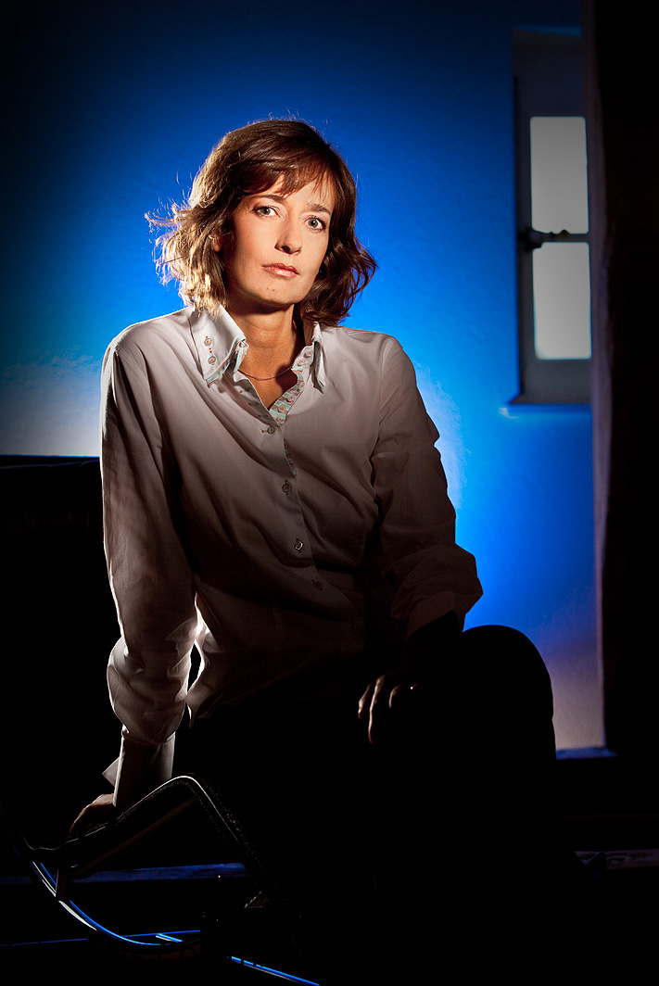
Born : Lausanne - Switzerland
Nationality : Swiss
Date of birth : 5th of May, 1970
Private : Single, in couple with Olivier Leu since 1997

1991-1994 : Art Center College of Design (Europe), Bachelor of Science
1994 – 1997 : Jaeger-LeCoultre, Product Designer
1997 – 1999 : Omega, Product Designer and Product Manager
1999 – 2002 : Audemars Piguet, Product Manager
2002-2007 : Marketing and creative consultant for wines and watches of Switzerland
2007 – Today : Founder of REVELATION

Significant projects:
JLC Atmos collections
Omega Constellation “My Choice” and Constellation jewellery lines
Omega Deville Co-Axial
Audemars Piguet first Royal Oak Concept, Offshore chrono caoutchouc for men and ladies
Audemars Piguet Jules Audemars Time Equation, QP Metro
Audemars Piguet Edward Piguet Tourbillon mineral, Canapé, Millenary

Both Anouk Danthe and Olivier Leu have the same creative background.
They attended the famous Art Center College of Design – an American design school based in Passadena Califorina, knows since the 30th to give an outstanding education in product, communication and transportation design as well as in all different majors for the movie industry.
Art Center College of Design opened an antenna in Europe between 1986 and 1996 : ACCD (Europe).

During their school years from 1991 to 1994, Olivier and Anouk were not yet a couple, just classmates.
In 1997, by chance, they met in a gas station both feeding up their cars and since that very moment continued their life together.
In 2007, after more than 10 years experience in the watch industry, they decided to create their own watch brand.

Olivier has been freelancing for more than 80 brands.
He created numbers of collections of watches as well as all the items necessary in the product environment of a brand such as: booth, furnitures, showcases, material for points of sales, jewellery boxes and various graphic supports.
The MAGICAL WATCH DIAL® concept, and the mechanism behind it, is his original idea.
For REVELATION, he is taking care of the design of the collections, the design and the concept of the product environment and the entire corporate identity of the brand.
He also manages the production dealing with the 40 suppliers necessary to produce one complete watch.

Thanks to her experience in the prestigious watch brands, Anouk is managing the marketing and administrative work.
She also participates in the creation process and help Olivier with details such as finding a good shape for a bridge, imagine the design of an index or an hand.
Her main task is building up the market and the distribution.
She got inspired by personalities such as Mr. Gunter Blümlein, who was the President of Jaeger-LeCoultre, IWC and wo relaunched the brand Lange & Söhne in the 90’s.
That is why she had not been scared to convince Olivier to start this amazing adventure: creating their own watch brands based on the innovative ideas of Olivier.

On the 31th of January 2007, CREATIONS HORLOGERES DE LULLY SA was born.
Under this administrative entity, Olivier and Anouk launched the watch brand REVELATION, they developed their own tailor made movement TOURBILLON MANEGE® and the unique nanotechnological MAGICAL WATCH DIAL®.
After 5 years of intense development, they were able to present during Baselworld 2012 the first talking piece R01 DOUBLE COMPLICATION, followed today by many very interesting and creative new collections.

